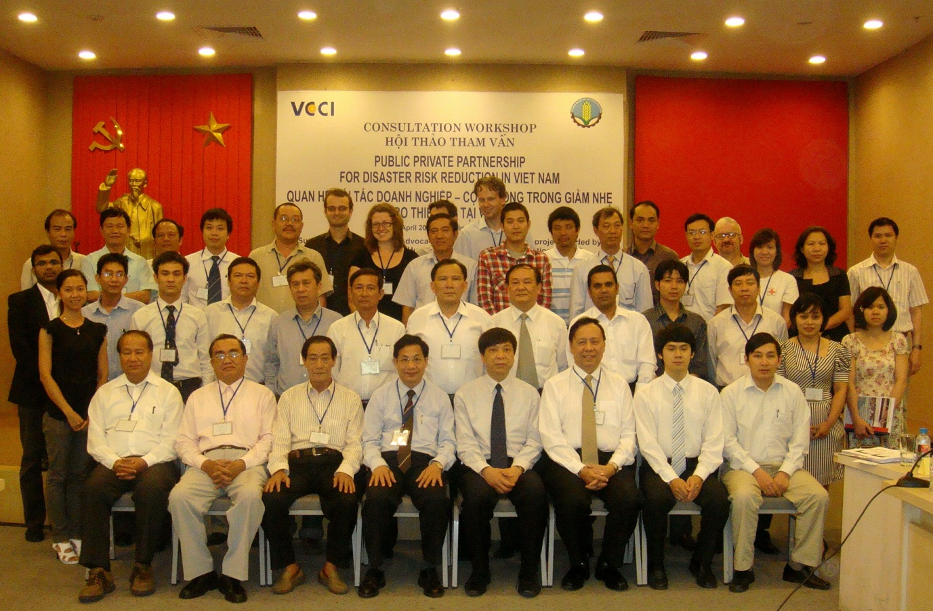
Under Joint Advocacy Networking Initiative (JANI)
With funding support from European Commission for Humanitarian Aid
ACTION PLAN
PUBLIC PRIVATE PARTNERSHIP FOR DISASTER RISK REDUCTION IN VIETNAM

Table of Contents
I. Background information: 2
II. Action Plan for Public Private Partnership for Disaster Risk Reduction in Vietnam 3
2.1. Objectives: 3
2.2. Goals: 3
2.3. Expected outcomes: 4
2.4. Participation approach: 4
2.5. Focal point agency: 4
2.6. Key Implementing partners: 4

- Background information:
In recent decades, natural disasters have increasingly happened in term of severity over the world, causing serious consequences to human life, especially to the poor. Disasters are natural phenomena; however their magnitude and consequences have been exacerbated due to human activities during the process of socio-economic development, with technologies, urbanization, population boom, and natural resources and environmental degradation. In the past 2 decades, more than 200 million people on average directly suffered from the consequences of natural disasters every year. Vietnam is located in the tropical monsoon area, one of the five storm-prone areas of the Asia Pacific region. Therefore the country often faces natural disasters of various types. In recent years, disasters have continually occurred all over the country, causing vast losses in human life, property, socio-economic and cultural infrastructure as well as environmental degradation.
Natural disaster in Vietnam is the direct impediment to the economic development, sustainable development and poverty reduction; the huge obstacle to the process of striving for the Millennium Development Goals. Vietnam has more than 80% of its population living at risk of direct impacts of natural disasters. Natural disaster has taken away many achievements of the national socio-economic development. Natural disaster intensifies the division in residents’ living standard; hinders and lowers the hunger eradication and poverty alleviation, especially in areas frequently at risk of disaster. On average, millions of people are in need of assistance due to natural disasters every year. Many of them, who have just escaped from poverty, are re-impoverished due to the disasters. Natural disaster affects educational development, destroys educational infrastructure and interrupts school time, especially in mountainous areas and the Mekong River Delta.
Since 2001, government agencies and many NGOs have made a lot of efforts in mitigating flood impacts. The Vietnamese government has issued a legal framework for disaster mitigation such as Law on Water Resource, Law on Land Use, Law on Forest Protection, Law on Environment Protection, Ordinances on Dyke protection and Flood and Storm Control. The National Strategy for Natural Disaster Prevention, Response and Mitigation to 2020 (in 2007) and the National Program on Community-based Disaster Risk Management (CBDRM in 2009) have been issued and all provinces are now preparing their provincial action plans to implement the National Strategy and the National program on CBDRM.
The Vietnam Government is committed to reduce the negative impact of floods and storms and initiated various program under the leadership of the Central Committee for Flood and Storm Control (CCFSC) through the Department of Dyke Management and Flood and Storm Control (DDMFSC). In addition to the national programmes, the provincial People Committee is playing an important role in providing resources in implementing various flood and storm control measures under the Annual Flood and Strom Control Plans prepared by each of the province. These activities are facilitated by the Provincial Committee of Flood and Storm Control (PCFSC) and its member agencies.
Public private partnership for disaster risk reduction is a good initiative applied in some countries in the world. In fact, it contributed to reinforce the resource of government in efforts of reducing negative impacts of disaster, thus, creat better and safer life for community at risk. In addition, the partnership also helped to strengthen cooperation and coordination between private sector and government. This also provided a better environment for private sector to do their bussiness while creating a good image of company in safer community against disaster.
In Vietnam, private companies did participate in disaster recovery and rehabilitation stages and provided many meaningful and effective reliefs to affected community. With the motto of taking preparedness as priority to reduce loss of life and property of community during disaster, in the Decision of implemeting National Program of CBDRM, at Section 6, Clause 2, it mentions about importance of private sector to participate in disaster risk reduction activities.

- Action Plan for Public Private Partnership for Disaster Risk Reduction in Vietnam
  - Objectives:
  - To achieve and maintain a meaningful association with variety of stakeholders including the corporate sector.
  - Contribute to the wellbeing of wider society in which business is part of a strong healthy social climate.
  - To sustain the nationally and externally aided DRR programs.
  - They believed that a good image of private sector will be created in customers’ feeling by involving in social activities.
  - To achieve the targets set in the National Strategies of the Government.
  - Implementation of their National CBDRM program.
  - To foster partnership for disaster preparedness and prevention.

  - Goals:
  - Build up partnership for disaster preparedness and prevention.
  - Strengthen disaster preparedness and prevention with participation of private sector.
  - The National Program on CBDRM implemented successfully and achieved it target goals.
  - Creat better, safer and better developed society, thus better bussiness environment for private sectors.

  - Expected outcomes:
  - Partnership between private sectors and government agency who in charge of disaster risk reduction developed.
  - Private sectors participated in implementing public awareness raising activities identified in National CBDRM program or new intiatives developed by private sectors.
  - With contribution from private sectors, target outcomes of Natinal CBDRM program achieved.
  - Images of benefactors will be strengthened in community while safer society built up.

  - Participation approach:
Direct or indirect participation can be applied. This means private sector can discuss with focal point agency and implementing partners to develop and implement a specific activity depends on their human resource, budget and mechanism, etc. Or the private sector can provide budget to support any of activity listed in the below Action Plan and provide fund to responsible agencies to implement it. While activities are being conducted, private sectors can also participate as monitoring and evaluation team.
In addition, private companies can also be actively design or propose new activities mainstreaming in existing activities of the companies. For example, messages of flood and storm prevention can be printed and stick on the products of the companies; or an example on backpack for school children can be used as floating objects which rescue children from drowing, etc.
  - Focal point agency:
Disaster Management Center, Water Resource Directorate, Ministry of Agriculture and Rural Development.
  - Key Implementing partners:
Vietnam Chamber of Commerce and Industry (VCCI)
Ministry of Education and Training
Ministry of Culture, Sport and Tourist
Ministry of Construction

ACTION PLAN
POSSIBLE ACTIVITIES FOR PARTICIPATION OF PRIVATE SECTOR
Activities selected from Action Plan of National CBDRM program (1002/QD-TTg) focus on Component 2 - Improvement of Educational information and capacity building on CBDRM for community. (Reference number of activities is in accordance to the activities in Action Plan of National CBDRM program.)
Activities |  | Sub- Activities | Focal agencies | Implementing partners | Role and responsibilities
 |  |  |  |  | Focal agencies/Implementing partners | Private sectors
Activities 2.1: Form CBDRM working groups in communities (selected by the communities) |  | Integrate disaster management information into Worker Union meeting | Disaster Management Center | VCCI | - Play consultation role to private companies on content to be disseminated to workers.  - Provide related information on disaster preparedness, response, recovery and climate changes to private companies.  - Can be facilitator/presenters for these meetings. | - Consult with focal agencies on information on disaster preparedness, response and recovery and climate change to private companies.  - Integrate content of disaster preparedness, response, recovery and climate changes into worker union meeting to help enhance their understanding on disaster impacts and environment protection.
 |  | Form emergency response groups in the company | Disaster Management Center | VCCI | - Provide consultation to private companies of approach of formulating emergency response groups such as identify role and responsibility, what kind of training skills this group should take, etc.  - In cooperation with VCCI to provide trainings for emergency response groups. | - Under technical consultation from DMC and VCCI, private companies form emergency response groups in their companies.  - Provide fund to conduct trainings for workers who are members of this emergency reponse group.
Activities 2.2: Establish hazard and vulnerability maps for each community (implemented by the community based on the guidance of the CBDRM working groups in the communities); develop map panels and direction boards on basic steps for preparation, response and recovery in the center of each community. |  | Installation of flood information billboards in community | Disaster Management Center | VCCI; Ministry of Culture, Sport and Tourist; target provinces | - Design/Provide information such as content, pictures, size, etc of the billboard and ensure legality of installation.  - Provide suggestion on provinces/location need billboard.  - Support procedure to install billboards. | Option 1:  '- Support budget for billboard designation and installation.  - Logo of sponsor companies will be printed on the billboard.  Option 2:  - Directly print content of billboard as per the design given by focal agency.  - Directly manage budget and expenses.  - Cooperate with relevant agencies to install billboard.  - Logo of sponsor companies will be printed on the billboard.
 |  | Installation of flood information billboards in company | Disaster Management Center | VCCI | - Provide consultation on content and messages to be on the billboards. | - Manage design and installation of billboards in their companies/branches.
 |  | Develop hazards and vulnerability maps for company | Disaster Management Center | VCCI | - Can provide consultation on development on this map, if necessary. | - In consultation with focal agency and implementing partners to develop harzards and vulnerability maps for their company.  - Provide orientation for workers/employers on how to use the maps.
Activities 2.3: Develop a handbook on basic implementation activities for the community on preparation, response and recovery relevant to pre-disaster, during-disaster and post-disaster periods appropriate to each commune (according to culture and socio-economic situation of each/group of the community) |  | Support Ministry of Agriculture and Rural Development to publish and print the handbook to distribute to community including workers | Disaster Management Center | VCCI | Option 1:  - Develop the handbook and print it with funding support from private companies  Option 2:  - Develop the handbook and provide soft copy to private companies for printing | Option 1:  - Provide funding support to focal agency to print the handbook.  - The handbooks can be distributed to the companies' workers.  Option 2:  - Receive soft copy of handbooks from focal agency.  - Consult on number of copy that companies can support to print.  - The companies print it and deliver to focal agency to distribute to community.
Activities 2.5: Communities develop annual plans on disaster prevention, response and management of the community. |  | Company has Contigency plan for emergency situation | Disaster Management Center | VCCI | - Provide orientation to private companies to develop Contigency plan for emergency situation.  - Share any information related to disaster such as storms, typhoon, flash flood, etc. | - Consult with focal agency to develop Contigency plan.  - Hold an orientation for related members in the company how to run the Contigency Plan.  - Disseminate to all workers/employers.
 |  | Company include disaster prevention activities into their sectoral annual development plan | Disaster Management Center | VCCI | - Share information on program/projects with specific action plan/activities so that companies can consider and select which activities they can participate and support. | - Update information on existing program/projects being conducted by government.  - Consider and select most appropriate activities and include it in companies' development plans.
Activities 2.6: Communities develop annual plans on disaster prevention, response and management, including climate change of the community. |  | Company include content of climate change into their annual development plan in consideration of managing waste to protect environment | Disaster Management Center | VCCI, Ministry of Natural Resource and Environment | - Share information on program/projects on climate change so that companies understand more and know what they should do. | - Update information on existing program/projects on climate change being conducted by government.  - Consider and select most appropriate activities and include it in companies' development plans.  - Consider environment protection in all manufactures.
Activities 2.7: Annually, develop simulation exercises on disaster prevention, response and management in community (including equipment and supporting instruments) |  | Sponsor for disaster preparedness and response simulation exercise in community | Disaster Management Center | VCCI, selected province/ districts/ communes | - If at national level, develop and share information of simulation with companies.  - If at sub-national levels, provide information on which provinces, districts or communes will conduct simulation to private company, once requested.  - Link companies with selected provinces/ districts/ communes | - If at national level, provide funding support to focal agency and participate in simulation either as participants or as observers.  - If at sub-national levels, provide funding support to focal agency for transferring to selected location; or directly provide funding support to selected location with help from focal agency.
 |  | Company organize disaster emergency response simulation exercise for their branch in provinces | Disaster Management Center | VCCI, local authorities | - Provide consultation to private companies to develop script of simulation exercise.  - Participate as Consultation Board and provide support to conduct it as per standards and correct actions | - Consult with focal agency and other implementing partners to develop script for simulation exercise.  - Conduct the exercise using fund of the companies.  - Provide support to government experts to participate and provide guidance during exercise to ensure safety and correct actions from employers.
 | Activities 2.8: Establish an early warning information system on disasters in the community (including equipment and supporting instruments) | Provide equipment support such as communication equipments, short-wave radio equipments for local authorities | Disaster Management Center | VCCI, local authorities | - Have a list of standard equipments need for early warning system.  - Share the list with provinces, and with private companies if requested.  - Request provinces to update on what is the need of equipments and compile in one file. | - Learn on what is the need of equipments requested by provinces.  - Based on possible funding support of the companies, select provinces to be provided requested equipments.  - The companies can either provide budget directly to provinces or purchase the equipments and deliver to provinces.
 |  | Upgrading of broadcasting station at village/commune levels to ensure information update to community | Disaster Management Center | VCCI, local authorities | - Have a list of standard equipments need for a broadcasting station.  - Share the list with provinces, and with private companies if requested.  - Request provinces to update on what is the need of equipments and compile in one file. | - Learn on what is the need of equipments requested by provinces.  - Based on possible funding support of the companies, select provinces to be provided requested equipments.  - The companies can either provide budget directly to provinces or purchase the equipments and deliver to provinces.
 | Activities 2.10: Regularly disseminate CBDRM activities through websites, television, radio, newspaper and panels, leaflets, etc. | Provide funding support to MARD to develop documentary on current disaster and climate change in Vietnam | Disaster Management Center | VCCI, related Ministries, VTV | - Develop documentary film on current disaster and climate change in Vietnam. | - Provide funding support to focal agency to develop the documentary film.  - Logos of sponsors companies must be attached to the documentary film as acknowledgement.
 |  | Provide funding support to MARD to post up the documentary film on VTV | Disaster Management Center | VTV, mass media | - Work with VTV or other media to prepare plan to post up the documentary film on television. | - Support budget to post information on TV or Radio.  - Logo and name of sponsor companies will be showed below or followed documentary film.
 |  | Hold Live Talk to discuss on disaster risk reduction related | Disaster Management Center | related Ministries, mass media, VTV | - Develop a plan for Live Talk.  - Consult and work with other related Ministries and mass media to develop the plan.  - Prepare of discussion points, guests, etc. including budget. | - Provide funding support to focal agency to conduct the Live Talk.  - Representative from private companies can participate in the Live Talk.  - Logo and name of sponsor companies will be announced/displayed in the Live Talk.
 |  | Provide funding support to MARD to develop Newsletter on disaster prevention update published every week | Disaster Management Center | Related Ministries, development organizations, networks | - Collect information from various sources and networking to update on existing disaster prevention and response activities.  - Develop and design to newsletter.  - Print and distribute it to provinces, partners, private companies, etc. | - Provide update information to focal agency on what the companies have done for disaster prevention and response.  - Consult with focal agency on number of copies of newsletters needed per week. Long term support must be applied to ensure smooth information.  - Provide funding support to focal agency to print and distribute newsletters.
 |  | Printing and distributing of IEC materials | Disaster Management Center | Related Ministries | Option 1:  - Develop new IEC materials or compiling the existing one and develop printing plan.  - Print IEC materials with funding support from private companies.  - Deliver the materials to provinces and companies.  Option 2:  - Develop new IEC materials or compiling the existing one and develop printing plan.  - Provide the printing plan and soft copies of materials to sponsor companies for printing. | Option 1:  - Review the printing plan from focal agency.  - Confirm number of copies of materials that company can support for printing.  - Provide logos and name of companies to focal agencies to put on the materials.  Option 2:  - Receive soft copies of materials and printing plan from focal agencies.  - Review and confirm number of copies that company can support for printing.  - Put logos and names of sponsors companies on the materials.  - Companies print it and deliver to community
 | Activities 2.11: Develop a set of training materials on CBDRM (this set of training materials will cover the DRM process, such as: planning preparation, planning, response activities during disaster, recovery activity after disaster) | Printing and distributing of CBDRM training materials | Disaster Management Center | VCCI | - Develop training materials on CBDRM.  - Design and prepare printing plan.  - Share the plan with private sector.  - Print and distribute with funding support from companies | - Consult with focal agency and implementing partners to review printing plan.  - Confirm number of copies can support.  - Provide funding support directly to focal agency.
 | Activities 2.12: Annually organize training courses for the community on specific activities on CBDRM (these training activities are for specific target groups in the community, such as men and women, school pupils, the elderly, etc.) | Printing and distributing of training materials for schools | Disaster Management Center | Ministry of Education and Training, VCCI | Option 1:  - Has training materials for schools ready.  - Prepare printing plan and share with implementing partners.  - Print and distribute to schools.  Option 2:  - Has training materials for school ready.  - Prepare printing plan and share with implementing partners.  - Provide soft copies of materials to sponsor companies to print and distribute it to provinces. | Option 1:  - Consult with focal agency and implementing partners on printing plan.  - Confirm number of copies can be supported.  - Private companies can select which province they want to support.  - Provide funding support directly to focal agency for printing materials.  Option 2:  - Consult with focal agency and implementing partners on printing plan.  - Confirm number of copies can be supported by the companies.  - Private companies can select which province they want to support.  - Recieve soft copies of materials from focal agency.  - Print and directly distribute it to selected provinces.
 |  | Provide funding support to organize Festival on School Disaster Safety Program in community | Disaster Management Center | Ministry of Education and Training, VCCI | - Cooperate with Ministry of Education and Training to develop a plan on enhancing capacity of school teachers and students on disaster risk reduction.  - The plan would include orientation workshop, school campaign, etc. as a process.  - Plan the budget required for each of school to organize the campaign.  - Share the plan with implementing partners and sponsor companies.  - Receive funding support from private companies (if provided directly), and transfer budget to selected schools.  - Provide consultation to local authorities to conduct the campaign accordingly. | - Consult with focal agency and implementing partners on capacity building plan for school teachers and students on disaster risk reduction.  - Review the plan and confirm number of schools that companies can support.  - Provide funding support to focal agency or directly to the provinces (depends on companies).  - In addition, the companies can also support their products which can be used as gift for children during campaign.
 | Activities 2.13: Organize performances and plays on disaster prevention, response and management in the community on the occasion of community festival days. | Cultural performance on disaster management and mitigation | Disaster Management Center | Ministry of Culture, Sport and Tourist, related agencies, VCCI, local authorities | - Have a plan of provinces need cultural performance.  - Provide guidance to selected provinces to prepare a plan for cultural performance including quantity, approach, budget, location, expected date, etc.  - Compile the plan and share to implementing agencies and private companies.  - Receive fund support from sponsor companies (if provided directly) and transfer budget to selected provinces. | - Consult with focal agency and implementing partners on cultural performance plans.  - The companies can select which provinces they want to provide support to implement cultural performance.  - Provide funding support through focal agency or directly transfer to selected provinces.
 | Activities 2.14: Develop small-scale works for disaster prevention, response and management in the community. | Small mitigation works for emergency kindergartens | Disaster Management Center | Ministry of Education and Training, VCCI and local authorities | - Consult with implementing partners to review on existing status of emergency kindergartens in provinces.  - Request selected provinces to prepare a list of emergency kindergarten need to be standardized.  - Provide the list to implementing partners and private companies.  - Provide guidance to selected provinces to prepare construction design for emergency kindergartens  - Support in conducting assessment before and after constructed.  - Receive funding support from private companies (if provided directly) and transfer to selected provinces.  - Or link the companies to selected provinces to direct funding transfer and works. | - Consult with focal agency and implementing partners to review documents on emergency kindergarten and construction design.  - Consider the priority and confirm how many emergency kindergartens that the companies can suppot.  - Participate in assessment team before and after construction.  - The companies can do monitoring during implementation of mitigation works.  - Provide funding support through focal agency or directly to selected provinces.  - Another option is that the companies can provide materials, instead of money, to construct the emergency kindergarten.
 |  | Development of dyke protecting agriculture or community-cluster | Disaster Management Center | Department of Dyke Management - Flood and Storm Control, local authorities | - Consult and cooperate with implementing partners to assess on need of having dyke in provinces.  - Make a clear list of type of dyke, priority levels, location, etc.  - Share the list with private companies and provide consultation.  - Support selected provinces to prepare documents on constructing dyke as standards and technique required with insurance of protecting human life and property from disaster while maintaining good production activities for community.  - Link the companies with selected provinces for funding transfer directly or receive fund from private companies.  - Hold assessment team before and after constructed.  - Provide guidance on Monitoring and Evaluation. | - Consult with focal agency and implementing partners to review documents on requested dyke and construction design.  - Consider the priority and confirm how many dyke that the companies can suppot.  - Participate in assessment team before and after construction.  - The companies can do monitoring during implementation of mitigation works.  - Provide funding support through focal agency or directly to selected provinces.  - Another option is that the companies can provide materials, instead of money, to construct the dyke.  - This activity can be done as cost-sharing basic between governement and private companies.
 |  | Develop of community houses for disaster prevention | Disaster Management Center | Ministry of Construction, VCCI, local authorities | - Consult with implementing partners on model of safety houses for community in response to disaster.  - Share the model and list of priority provinces for safety houses for community to private companies.  - Provide guidance to selected provinces on developing construction documents, bid calling, estimate cost, etc.  - Set up assessment team and M&E team with participation of sponsor companies.  - | - Consult with focal agency and implementing partners to review documents on safe houses for community and construction design.  - Consider the priority and confirm how many houses that the companies can suppot.  - Participate in assessment team before and after construction.  - The companies can do monitoring during implementation of mitigation works.  - Provide funding support through focal agency or directly to selected provinces.  - Another option is that the companies can provide materials, instead of money, to construct the dyke. Or in case the companies are professional on construction, they can build the houses by themselves.  - This activity can be done as cost-sharing basic between governement and private companies.

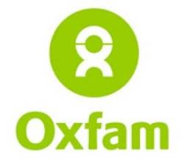 |  |  | 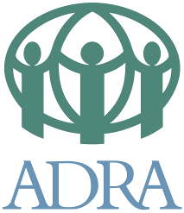 | 
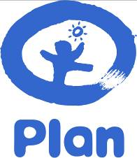 |  | JANI  Joint  Advocacy  Networking Initiative | 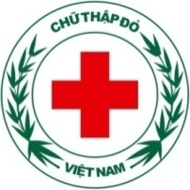 | 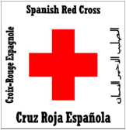
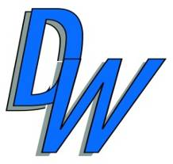 |  | 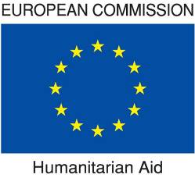 | 
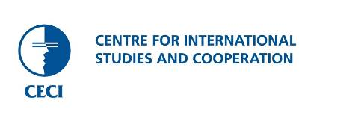 |  | 

